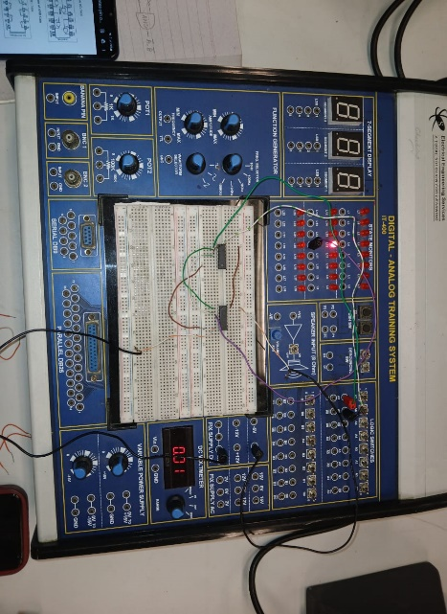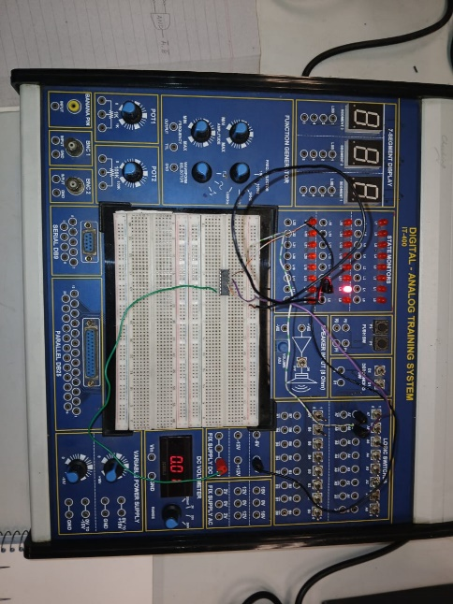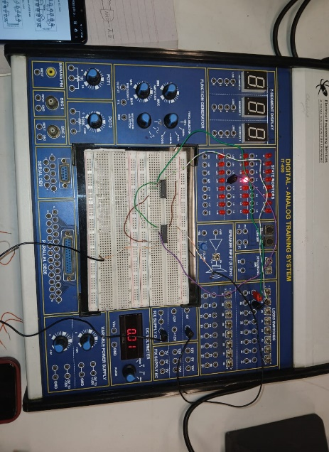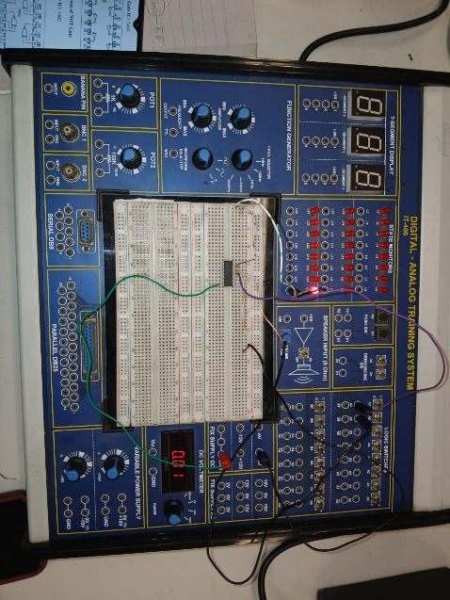**LAB 5 PHOTOGRAPHS**

=

NAND Gate

OR Gate with Inverted inputs

**DE MORGAN’S 2nd THEORM:**

NOR Gate

AND Gate with Inverted inputs

=

**DE MORGAN’S 1st THEORM:**